|  |  |  |  |
| --- | --- | --- | --- |
| logo ngan.png | | **MINISTRY OF EDUCATION AND TRAINING** | |
| **FPT UNIVERSITY** | |
| **CAPSTONE PROJECT DOCUMENT** | |
| **BUILDING A WEBSITE SUPPORT THE ACTIVITIES “TIẾP SỨC MÙA THI” CAMPAIGN**  **Project Report #3 – System Requirements Specifications** | |
|  | |
| |  |  | | --- | --- | | **Group 22** | | | **Group Members** | |  |  | | --- | --- | | SE60769 | Nguyen Duy Khoa | | SE60687 | Le Nguyen Huu Tri | | 60358 | Nguyen Dinh Tuan | | 60325 | Tran Nguyen Kim Vinh | | 60339 | Nguyen Vinh Hien | | | **Supervisor** | Nguyen Trong Tai | | **Ext Supervisor** | N/A | | **Capstone Project Code** | TSMT | | |
| - Ho Chi Minh City, February 2014 - | |

Table of Contents

3. Software Requirement Specification 3

3.1. User Requirement Specification 3

3.1.1. Guest Requirements 3

3.1.2. Authorized User Requirements 3

3.1.3. Candidate Requirements 3

3.1.4. Charity Requirements 3

3.1.5. Volunteer Requirements 3

3.1.6. Sponsor Requirements 3

3.1.7. Admin Requirements 3

3.2. System Requirement Specification (Specific Requirements) 3

3.2.1. External Interface Requirements 3

3.2.2. Functional Requirements 3

3.2.3. Non-functional Requirements 3

3.3. Entity Relationship Diagram or Data Structure 4

3.3.1. Entity Relationship Diagram 4

3.3.2. Entity Detail 4

# SOFTWARE REQUIREMENT SPECIFICATION

## User Requirement Specification

### Guest Requirements

### Authorized User Requirements

### Candidate Requirements

### Charity Requirements

### Volunteer Requirements

### Sponsor Requirements

### Admin Requirements

## System Requirement Specification (Specific Requirements)

### External Interface Requirements

#### User Interfaces

#### Hardware Interfaces

#### System Interfaces

#### Communication Protocol

### Main Flow Overviews

### Functional Requirements

#### Overall Use case diagram

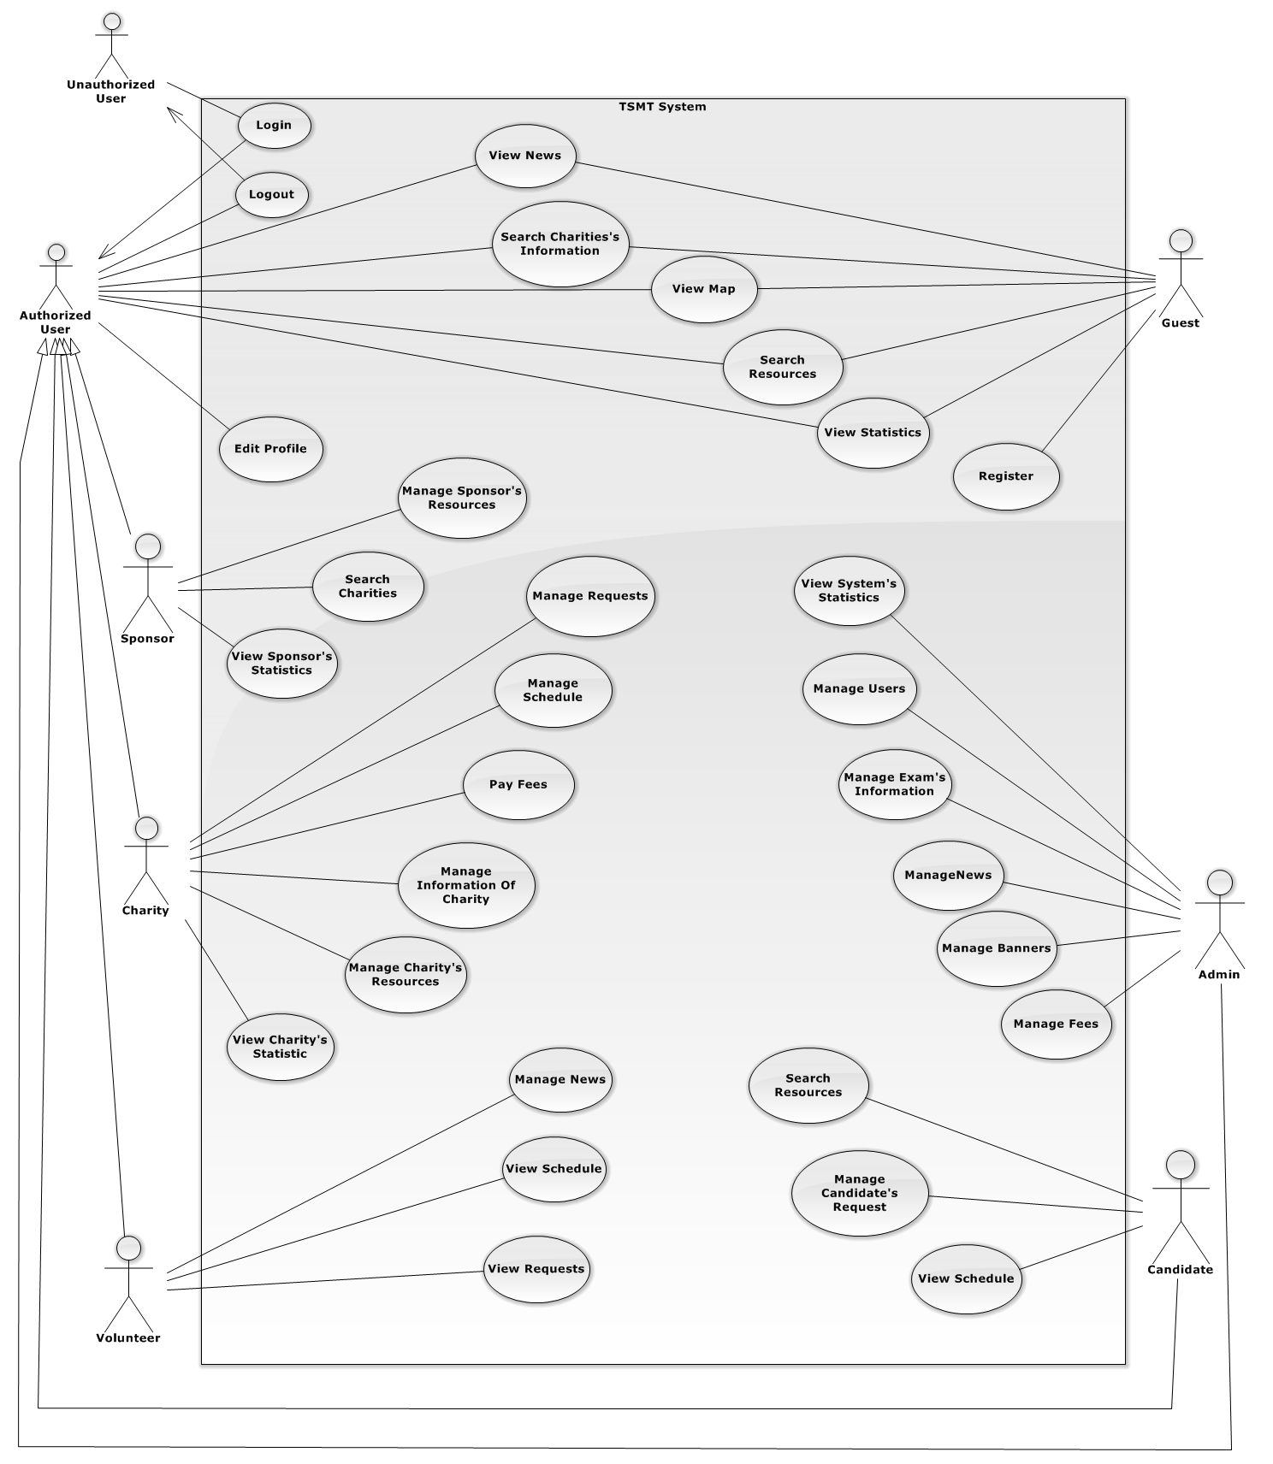

#### ⏪Unauthorized User⏩ Login

#### ⏪Authorized User⏩ View News

#### ⏪Authorized User⏩ Search Charity’s Information

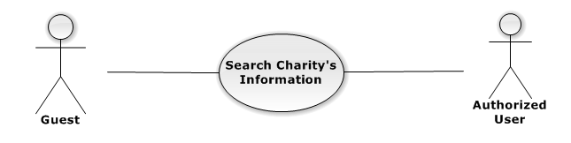

Figure 3.2.2 – Authorized User Search Charity’s Information use-case diagram

|  |  |  |  |  |
| --- | --- | --- | --- | --- |
| **USE CASE-UC01 SPECIFICATION** | | | | |
| **Use-case No.** | UC01 | **Use-case Version** | | v0.1 |
| **Use-case Name** | Search Charity’s Information | | | |
| **Author** | Nguyen Vinh Hien | | | |
| **Date** | 13/02/2014 | **Priority** | High | |
| **Actor:**  Authorized User  **Summary:**  Authorized User can search charity’s information of the system  **Goal:**  Helps authorized user to search charity’s information of system more easier  **Triggers:**  Authorized User want to see the charity’s information that exist in the system  (guest inputs key words on textbox then clicks “Tìm kiếm” icon at the right corner of frame to search follow key words inputted)  **Preconditions:**  Login success with any role  The page is fully loaded.  **PostConditions:**   * Success: * Charity’s information of the system are displayed as thumbnails. * Charity’s information are displayed correctly corresponding to optional inputted * Failure: N/A   **Main Success Scenario:**   |  |  | | --- | --- | | Actor Actions | System Response | | 1. Authorized User input key words into textbox  [Alternative1] [Alternative2]  2. Authorized User click "Search" icon | 3. Display charity’s information matches key words or options that user selected in step 1 in thumbnails icon. |   **Alternative Scenario:**   |  |  | | --- | --- | | Ator Actions | System Response | | [Alternative 1]  1. Authorized User choose district check box  [Alternative 2]  1. Authorized check on exam check box | 2. List charity in the district matches with check box that user selected  2. Filter charity support for the exam season that user selected. |   **Exceptions:**   |  |  | | --- | --- | |  |  | | Actor Actions | System Response | | N/A | N/A |   **Relationships:** N/A  **Business Rules:**  Authorized User can search charity’s information with many options selected  Inputted key words have to match at least one charity or meaning words | | | | |

#### ⏪Authorized User⏩ View Map

#### ⏪Authorized User⏩ Search Resource

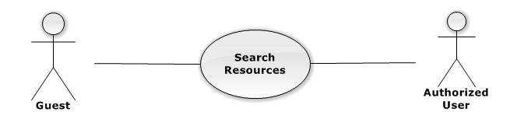

Figure 3.2.2 – Authorized User Search Resources use-case diagram

|  |  |  |  |  |
| --- | --- | --- | --- | --- |
| **USE CASE-UC02 SPECIFICATION** | | | | |
| **Use-case No.** | UC02 | **Use-case Version** | | v0.1 |
| **Use-case Name** | Search Resources | | | |
| **Author** | Nguyen Vinh Hien | | | |
| **Date** | 13/02/2014 | **Priority** | High | |
| **Actor:**  Authorized User  **Summary:**  Authorized user can search resources(lodges, cars) of the system  **Goal:**  Helps authorized user to search resources of system more easier  **Triggers:**  Authorized user want to see the resources that charities will support  (authorized user inputs key words on textbox then clicks “Tìm kiếm” icon at the right corner of frame to search follow key words inputted)  **Preconditions:**  Login success with any role  The page is fully loaded.  **PostConditions:**   * Success: * Resources of the system are displayed as thumbnails. * Resources are displayed correctly corresponding to optional inputted * Failure: N/A   **Main Success Scenario:**   |  |  | | --- | --- | | Actor Actions | System Response | | 1. Authorized input key words into textbox  [Alternative1] [Alternative2]  2. Authorized click "Search" icon | 3. Display resources match key words or options that user selected in step 1 in thumbnails icon. |   **Alternative Scenario:**   |  |  | | --- | --- | | Ator Actions | System Response | | [Alternative 1]  1. Authorized choose “Lodge” check box  [Alternative 2]  1. Authorized check on “Car” check box | 2. List of lodges of the system is showed  2. List of cars of the system is showed |   **Exceptions:**   |  |  | | --- | --- | |  |  | | Actor Actions | System Response | | N/A | N/A |   **Relationships:** N/A  **Business Rules:**  Authorized can search resources with many options selected  Inputted key words have to match at least one resource or meaning words | | | | |

#### ⏪Authorized User⏩ View Statistics

#### ⏪Authorized User⏩ Comment

#### ⏪Authorized User⏩ Edit Profile

#### ⏪Authorized User⏩ Logout

#### ⏪Guest⏩ Register

#### ⏪Guest⏩ Search Charity’s Information



Figure 3.2.2 – Guest Search Charity’s Information use-case diagram

|  |  |  |  |  |
| --- | --- | --- | --- | --- |
| **USE CASE-UC03 SPECIFICATION** | | | | |
| **Use-case No.** | UC03 | **Use-case Version** | | v0.1 |
| **Use-case Name** | Search Charity’s Information | | | |
| **Author** | Nguyen Vinh Hien | | | |
| **Date** | 13/02/2014 | **Priority** | High | |
| **Actor:**  Guest  **Summary:**  Guest can search charity’s information of the system  **Goal:**  Helps guest to search charity’s information of system more easier  **Triggers:**  guest want to see the charity’s information that exist in the system  (guest inputs key words on textbox then clicks “Tìm kiếm” icon at the right corner of frame to search follow key words inputted)  **Preconditions:**  The page is fully loaded.  **PostConditions:**   * Success: * Charity’s information of the system are displayed as thumbnails. * Charity’s information are displayed correctly corresponding to optional inputted * Failure: N/A   **Main Success Scenario:**   |  |  | | --- | --- | | Actor Actions | System Response | | 1. Guest input key words into textbox  [Alternative1] [Alternative2]  2. Guest click "Search" icon | 3. Display charity’s information matches key words or options that user selected in step 1 in thumbnails icon. |   **Alternative Scenario:**   |  |  | | --- | --- | | Ator Actions | System Response | | [Alternative 1]  1. Guest choose district check box  [Alternative 2]  1. Guest check on exam check box | 2. List charity in the district matches with check box that user selected  2. Filter charity support for the exam season that user selected. |   **Exceptions:**   |  |  | | --- | --- | |  |  | | Actor Actions | System Response | | N/A | N/A |   **Relationships:** N/A  **Business Rules:**  Guest can search charity’s information with many options selected  Inputted key words have to match at least one charity or meaning words | | | | |

#### ⏪Guest⏩ Search Resources



Figure 3.2.2 – Guest Search Resources use-case diagram

|  |  |  |  |  |
| --- | --- | --- | --- | --- |
| **USE CASE-UC04 SPECIFICATION** | | | | |
| **Use-case No.** | UC04 | **Use-case Version** | | v0.1 |
| **Use-case Name** | Search Resources | | | |
| **Author** | Nguyen Vinh Hien | | | |
| **Date** | 13/02/2014 | **Priority** | High | |
| **Actor:**  Guest  **Summary:**  Guest user can search resources(lodges, cars) of the system  **Goal:**  Helps guest to search resources of system more easier  **Triggers:**  guest want to see the resources that charities will support  (guest inputs key words on textbox then clicks “Tìm kiếm” icon at the right corner of frame to search follow key words inputted)  **Preconditions:**  The page is fully loaded.  **PostConditions:**   * Success: * Resources of the system are displayed as thumbnails. * Resources are displayed correctly corresponding to optional inputted * Failure: N/A   **Main Success Scenario:**   |  |  | | --- | --- | | Actor Actions | System Response | | 1. Guest input key words into textbox  [Alternative1] [Alternative2]  2. Guest click "Search" icon | 3. Display resources match key words or options that user selected in step 1 in thumbnails icon. |   **Alternative Scenario:**   |  |  | | --- | --- | | Ator Actions | System Response | | [Alternative 1]  1. Guest choose “Lodge” check box  [Alternative 2]  1. Guest check on “Car” check box | 2. List of lodges of the system is showed  2. List of cars of the system is showed |   **Exceptions:**   |  |  | | --- | --- | |  |  | | Actor Actions | System Response | | N/A | N/A |   **Relationships:** N/A  **Business Rules:**  Guest can search resources with many options selected  Inputted key words have to match at least one resource or meaning words | | | | |

#### ⏪Guest, Authorized User⏩ View Map

#### ⏪Guest, Authorized User⏩ View News

#### ⏪Guest, Authorized User⏩ View Statistics

#### ⏪Charity⏩ Manage Charity’s Information

#### ⏪Charity⏩ Manage Request

#### ⏪Charity⏩ Manage Resource⏪Charity⏩ Manage Resource

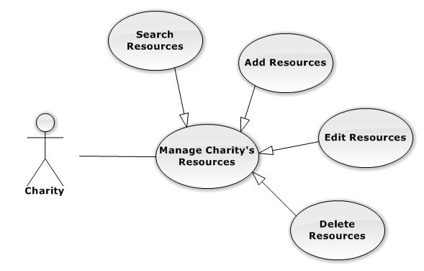

⏪Charity⏩ Search Resource

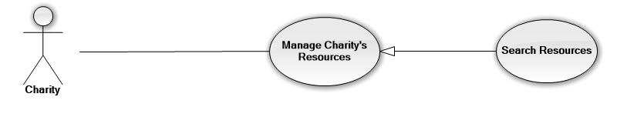

Figure 3.2.2 – Charity Search Resources use-case diagram

|  |  |  |  |  |
| --- | --- | --- | --- | --- |
| **USE CASE-UC05 SPECIFICATION** | | | | |
| **Use-case No.** | UC05 | **Use-case Version** | | v0.1 |
| **Use-case Name** | Search Resources | | | |
| **Author** | Nguyen Vinh Hien | | | |
| **Date** | 13/02/2014 | **Priority** | High | |
| **Actor:**  Charity  **Summary:**  Charities can search their resources(lodges, cars)  **Goal:**  Helps charities to search their resources more easier  **Triggers:**  Charities want to see the resources that they have  (charity inputs key words on textbox then clicks “Tìm kiếm” icon at the right corner of frame to search follow key words inputted)  **Preconditions:**  Login success with role charity  The page is fully loaded.  **PostConditions:**   * Success: * Resources of this charity are displayed as list. * Resources are displayed correctly corresponding to optional inputted * Failure: N/A   **Main Success Scenario:**   |  |  | | --- | --- | | Actor Actions | System Response | | 1. Charity input key words into textbox  [Alternative1] [Alternative2]  2. Charity click "Search" icon | 3. Display resources match key words or options that user selected in step 1 in thumbnails icon. |   **Alternative Scenario:**   |  |  | | --- | --- | | Ator Actions | System Response | | [Alternative 1]  1. Charity choose “Lodge” check box  [Alternative 2]  1. Charity check on “Car” check box | 2. List of lodges of charity is showed  2. List of cars of charity is showed |   **Exceptions:**   |  |  | | --- | --- | |  |  | | Actor Actions | System Response | | N/A | N/A |   **Relationships:** N/A  **Business Rules:**  Charities can search their resources with many options selected  Inputted key words have to match at least one resource or meaning words | | | | |

#### ⏪Charity⏩ Manage Schedule

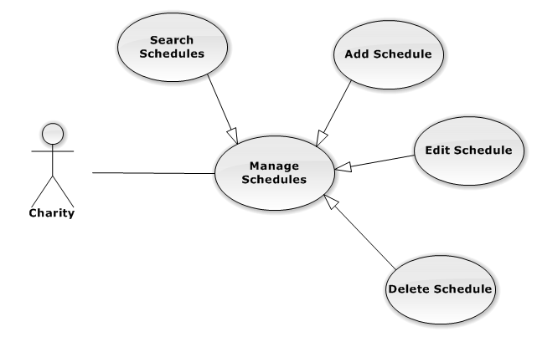

3.2.4.20.1. <<Charity>> Search Schedule



Figure 3.2.2 – Charity Search Schedules use-case diagram

|  |  |  |  |  |
| --- | --- | --- | --- | --- |
| **USE CASE-UC06 SPECIFICATION** | | | | |
| **Use-case No.** | UC06 | **Use-case Version** | | v0.1 |
| **Use-case Name** | Search Schedules | | | |
| **Author** | Nguyen Vinh Hien | | | |
| **Date** | 13/02/2014 | **Priority** | High | |
| **Actor:**  Charity  **Summary:**  Charities can search schedule of the charities process  **Goal:**  Helps charities to search their schedule more easier  **Triggers:**  Charities want to see the schedule that they have  (charity inputs key words on textbox then clicks “Tìm kiếm” icon at the right corner of frame to search follow key words inputted)  **Preconditions:**  Login success with role charity  The page is fully loaded.  .  **PostConditions:**   * Success: * Schedules of this charity are displayed as table. * Schedules are displayed correctly corresponding to optional inputted * Failure: N/A   **Main Success Scenario:**   |  |  | | --- | --- | | Actor Actions | System Response | | 1. Charity input key words into textbox  [Alternative1] [Alternative2]  2. Guest click "Search" icon | 3. Display schedules match key words or options that user selected in step 1 in table content. |   **Alternative Scenario:**   |  |  | | --- | --- | | Ator Actions | System Response | | [Alternative 1]  1. Guest choose date at “Date” tab  [Alternative 2]  1. Guest choose exam season at “Exam Season” check box | 2. List of schedules in that day are showed  2. List of schedules that match with this exam season is showed |   **Exceptions:**   |  |  | | --- | --- | |  |  | | Actor Actions | System Response | | N/A | N/A |   **Relationships:** N/A  **Business Rules:**  Charities can search their schedules with many options selected  Inputted key words have to match at least one schedules or meaning words | | | | |

#### ⏪Charity⏩ Pay Fees

#### ⏪Charity⏩ View Charity’s Statistics

#### ⏪Sponsor⏩ Manage Sponsor’s Resources

#### ⏪Sponsor⏩ Search Charity

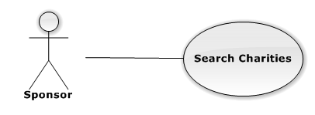

Figure 3.2.2 – Sponsor Search Charities use-case diagram

|  |  |  |  |  |
| --- | --- | --- | --- | --- |
| **USE CASE-UC07 SPECIFICATION** | | | | |
| **Use-case No.** | UC07 | **Use-case Version** | | v0.1 |
| **Use-case Name** | Search Charities | | | |
| **Author** | Nguyen Vinh Hien | | | |
| **Date** | 13/02/2014 | **Priority** | High | |
| **Actor:**  Sponsor  **Summary:**  Sponsor can search charities of the system  **Goal:**  Helps sponsor to search charities of system more easier  **Triggers:**  Sponsor want to see the charities that exist in the system  (sponsor inputs key words on textbox then clicks “Tìm kiếm” icon at the right corner of frame to search follow key words inputted)  **Preconditions:**  Login success with role sponsor  The page is fully loaded.  **PostConditions:**   * Success: * Charities of the system are displayed as thumbnails. * Charities are displayed correctly corresponding to optional inputted * Failure: N/A   **Main Success Scenario:**   |  |  | | --- | --- | | Actor Actions | System Response | | 1. Sponsor input key words into textbox  [Alternative1] [Alternative2]  2. Sponsor click "Search" icon | 3. Display charities have name matches key words or options that user selected in step 1 in thumbnails icon. |   **Alternative Scenario:**   |  |  | | --- | --- | | Ator Actions | System Response | | [Alternative 1]  1. Sponsor choose district check box  [Alternative 2]  1. Sponsor check on exam check box | 2. List charity in the district matches with check box that user selected  2. Filter charity support for the exam season that user selected. |   **Exceptions:**   |  |  | | --- | --- | |  |  | | Actor Actions | System Response | | N/A | N/A |   **Relationships:** N/A  **Business Rules:**  Sponsor can search charities with many options selected  Inputted key words have to match at least one charity or meaning words | | | | |

#### ⏪Sponsor⏩ View Sponsor’s Statistics

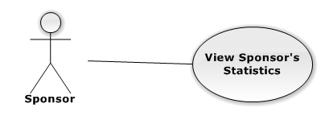

Figure 3.2.2 – Sponsor View Sponsor’s Statistics use-case diagram

|  |  |  |  |  |
| --- | --- | --- | --- | --- |
| **USE CASE-UC07 SPECIFICATION** | | | | |
| **Use-case No.** | UC08 | **Use-case Version** | | v0.1 |
| **Use-case Name** | View Sponsor’s Statistics | | | |
| **Author** | Nguyen Vinh Hien | | | |
| **Date** | 13/02/2014 | **Priority** | High | |
| **Actor:**  Sponsor  **Summary:**  Sponsor can view statistics of their resources  **Goal:**  Helps sponsor to view their statistics more clearly  **Triggers:**  Sponsor want to see the statistics ò their resources ( user for how many candidate, how many resource and quality,…etc…)  (sponsor click on “Thống Kê” tab at the top of the screen to view sponsor’s statistics)  **Preconditions:**  Login success with role sponsor  The page is fully loaded.  **PostConditions:**   * Success: * All the data of sponsor’s statistics are displayed as graph. * All the data of sponsor’s statistics are displayed correctly and clearly * Failure: N/A   **Main Success Scenario:**   |  |  | | --- | --- | | Actor Actions | System Response | | 1. Sponsor click on “ Thống Kê” tab at the top of the screen | 2. Display charities have name matches key words or options that user selected in step 1 in thumbnails icon. |   **Alternative Scenario:**   |  |  | | --- | --- | | Actor Actions | System Response | | N/A | N/A |   **Exceptions:**   |  |  | | --- | --- | |  |  | | Actor Actions | System Response | | N/A | N/A |   **Relationships:** N/A  **Business Rules:**  Sponsors can see all the data of their statistics with many style of graph | | | | |

#### ⏪Volunteer⏩ Manage News

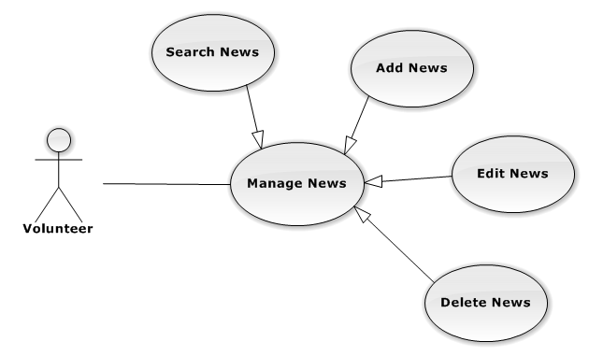

3.2.4.26.1 <<Volunteer>> Search News



Figure 3.2.2 – Volunteer Search News use-case diagram

|  |  |  |  |  |
| --- | --- | --- | --- | --- |
| **USE CASE-UC09 SPECIFICATION** | | | | |
| **Use-case No.** | UC09 | **Use-case Version** | | v0.1 |
| **Use-case Name** | Search News | | | |
| **Author** | Nguyen Vinh Hien | | | |
| **Date** | 13/02/2014 | **Priority** | High | |
| **Actor:**  Volunteer  **Summary:**  Volunteer can search news of the system  **Goal:**  Helps volunteer to search news of system more easier  **Triggers:**  Volunteer want to see the news in the system  (Volunteer inputs key words on textbox then clicks “Tìm kiếm” icon at the right corner of frame to search follow key words inputted)  **Preconditions:**  Login success with role volunteer  The page is fully loaded.  **PostConditions:**   * Success: * News of the system are displayed as list. * News are displayed correctly corresponding to optional inputted * Failure: N/A   **Main Success Scenario:**   |  |  | | --- | --- | | Actor Actions | System Response | | 1. Volunteer input key words into textbox  [Alternative1] [Alternative2]  2. Volunteer click "Search" icon | 3. Display news have name matches key words or options that user selected in step 1 in thumbnails icon. |   **Alternative Scenario:**   |  |  | | --- | --- | | Ator Actions | System Response | | [Alternative 1]  1. Volunteer choose category(charity/exam/food store/sponsor) at the top of the screen  [Alternative 2]  1. Volunteer click “ next page” icon | 2. List of news matches with category that user selected is displayed  2. The second page of news is displayed |   **Exceptions:**   |  |  | | --- | --- | |  |  | | Actor Actions | System Response | | N/A | N/A |   **Relationships:** N/A  **Business Rules:**  Volunteer can search news with many options selected  Inputted key words have to match at least one charity or meaning words | | | | |

#### ⏪Volunteer⏩ View Request

#### ⏪Volunteer⏩ View Schedule

#### ⏪Candidate⏩ Manage Candidate’s Request

#### ⏪Candidate⏩ View Schedule

#### ⏪Candidate⏩ Search Resource



Figure 3.2.2 – Candidate Search Resources use-case diagram

|  |  |  |  |  |
| --- | --- | --- | --- | --- |
| **USE CASE-UC10 SPECIFICATION** | | | | |
| **Use-case No.** | UC10 | **Use-case Version** | | v0.1 |
| **Use-case Name** | Search Resources | | | |
| **Author** | Nguyen Vinh Hien | | | |
| **Date** | 13/02/2014 | **Priority** | High | |
| **Actor:**  Candidate  **Summary:**  Candidates can search resources(lodges, cars) of the system  **Goal:**  Helps candidates to search resources more easier  **Triggers:**  Candidates want to see the resources that exist in the system  (candidate inputs key words on textbox then clicks “Tìm kiếm” icon at the right corner of frame to search follow key words inputted)  **Preconditions:**  Login success with role candidate  The page is fully loaded.  **PostConditions:**   * Success: * Resources of the system are displayed as list. * Resources are displayed correctly corresponding to optional inputted * Failure: N/A   **Main Success Scenario:**   |  |  | | --- | --- | | Actor Actions | System Response | | 1. Candidate input key words into textbox  [Alternative1] [Alternative2]  2. Candidate click "Search" icon | 3. Display resources match key words or options that user selected in step 1 in thumbnails icon. |   **Alternative Scenario:**   |  |  | | --- | --- | | Ator Actions | System Response | | [Alternative 1]  1. Candidate choose “Lodge” check box  [Alternative 2]  1. Candidate check on “Car” check box | 2. List of lodges of charity is showed  2. List of cars of charity is showed |   **Exceptions:**   |  |  | | --- | --- | |  |  | | Actor Actions | System Response | | N/A | N/A |   **Relationships:** N/A  **Business Rules:**  Candidate can search resources with many options selected  Inputted key words have to match at least one resource or meaning words | | | | |
|  | | | | |
|  | | | | |

#### ⏪Admin⏩ Manage Advertising

#### ⏪Admin⏩ Manage Exam’s Information

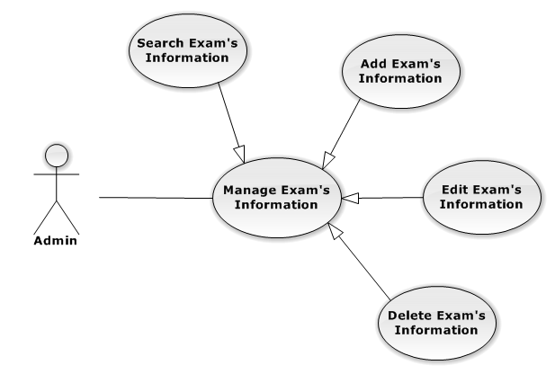

3.2.4.33.1. <<Admin>> Search Exam’s Information

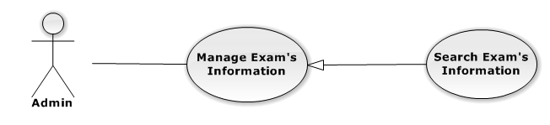

Figure 3.2.2 – Admin Search Exam use-case diagram

|  |  |  |  |  |
| --- | --- | --- | --- | --- |
| **USE CASE-UC11 SPECIFICATION** | | | | |
| **Use-case No.** | UC11 | **Use-case Version** | | v0.1 |
| **Use-case Name** | Search Exam | | | |
| **Author** | Nguyen Vinh Hien | | | |
| **Date** | 13/02/2014 | **Priority** | High | |
| **Actor:**  Admin  **Summary:**  Admin can search exam of the system  **Goal:**  Helps admin to search exam’s information more easier  **Triggers:**  Admin want to see the exam that exist in the system  (Admin inputs key words on textbox then clicks “Tìm kiếm” icon at the right corner of frame to search follow key words inputted)  **Preconditions:**  Login success with role admin  The page is fully loaded.  **PostConditions:**   * Success: * Exams of the system are displayed as list. * Exam displayed correctly corresponding to optional inputted * Failure: N/A   **Main Success Scenario:**   |  |  | | --- | --- | | Actor Actions | System Response | | 1. Admin input key words into textbox  2. Admin click "Search" icon | 3. Display exams match key words or options that user selected in step 1 in thumbnails icon. |   **Alternative Scenario:**   |  |  | | --- | --- | | Ator Actions | System Response | | N/A |  |   **Exceptions:**   |  |  | | --- | --- | |  |  | | Actor Actions | System Response | | N/A | N/A |   **Relationships:** N/A  **Business Rules:**  Admin can search exams easier  Inputted key words have to match at least one resource or meaning words | | | | |
|  | | | | |

#### ⏪Admin⏩ Manage News

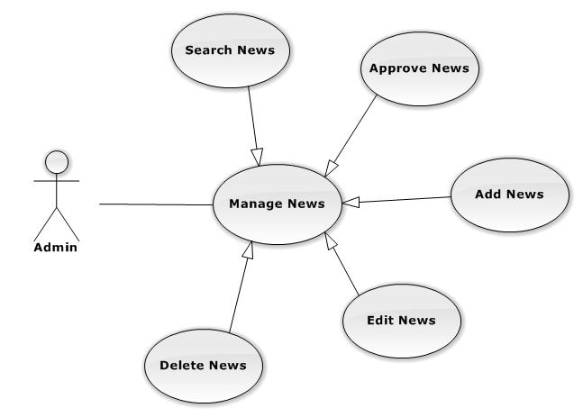

3.2.4.34.1 <<Admin>> Search News



Figure 3.2.2 – Admin Search News use-case diagram

|  |  |  |  |  |
| --- | --- | --- | --- | --- |
| **USE CASE-UC12 SPECIFICATION** | | | | |
| **Use-case No.** | UC12 | **Use-case Version** | | v0.1 |
| **Use-case Name** | Search News | | | |
| **Author** | Nguyen Vinh Hien | | | |
| **Date** | 13/02/2014 | **Priority** | High | |
| **Actor:**  Admin  **Summary:**  Admin can search news of the system  **Goal:**  Helps Admin to search news of system more easier  **Triggers:**  Admin want to see the news in the system  (Admin inputs key words on textbox then clicks “Tìm kiếm” icon at the right corner of frame to search follow key words inputted)  **Preconditions:**  Login success with role admin  The page is fully loaded.  **PostConditions:**   * Success: * News of the system are displayed as list. * News are displayed correctly corresponding to optional inputted * Failure: N/A   **Main Success Scenario:**   |  |  | | --- | --- | | Actor Actions | System Response | | 1. Admin input key words into textbox  [Alternative1] [Alternative2]  2. Admin click "Search" icon | 3. Display news have name matches key words or options that user selected in step 1 in thumbnails icon. |   **Alternative Scenario:**   |  |  | | --- | --- | | Ator Actions | System Response | | [Alternative 1]  1. Admin choose category(charity/exam/food store/sponsor) at the top of the screen  [Alternative 2]  1. Volunteer choose “Not yet approved” icon | 2. List of news matches with category that user selected is displayed  2. List of news that not yet approve will be displayed |   **Exceptions:**   |  |  | | --- | --- | |  |  | | Actor Actions | System Response | | N/A | N/A |   **Relationships:** N/A  **Business Rules:**  Admin can search news with many options selected  Inputted key words have to match at least one charity or meaning words | | | | |

#### ⏪Admin⏩ Manage User

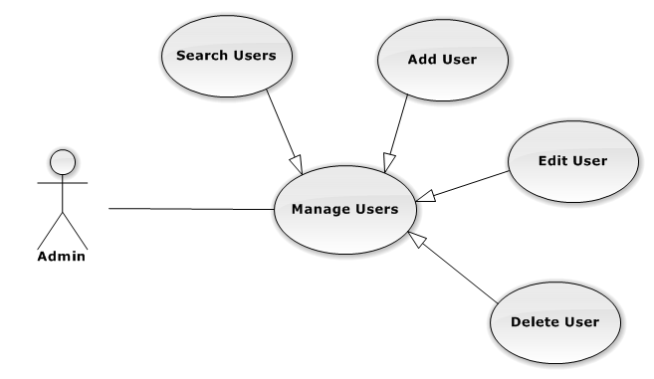

3.2.4.35.1. <<Admin>> Search Users

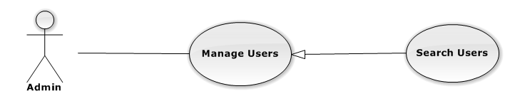

Figure 3.2.2 – Admin Search Users use-case diagram

|  |  |  |  |  |
| --- | --- | --- | --- | --- |
| **USE CASE-UC13 SPECIFICATION** | | | | |
| **Use-case No.** | UC13 | **Use-case Version** | | v0.1 |
| **Use-case Name** | Search Users | | | |
| **Author** | Nguyen Vinh Hien | | | |
| **Date** | 13/02/2014 | **Priority** | High | |
| **Actor:**  Admin  **Summary:**  Admin can search users of the system  **Goal:**  Helps Admin to search users of system more easier  **Triggers:**  Admin want to see the users of the system  (Admin inputs key words on textbox then clicks “Tìm kiếm” icon at the right corner of frame to search follow key words inputted)  **Preconditions:**  Login success with role admin  The page is fully loaded.  **PostConditions:**   * Success: * Users of the system are displayed as list. * Users are displayed correctly corresponding to optional inputted * Failure: N/A   **Main Success Scenario:**   |  |  | | --- | --- | | Actor Actions | System Response | | 1. Admin input key words into textbox  [Alternative1]  2. Admin click "Search" icon | 3. Display users have name matches key words or options that user selected in step 1 in thumbnails icon. |   **Alternative Scenario:**   |  |  | | --- | --- | | Ator Actions | System Response | | [Alternative 1]  1. Admin choose active/inactive check box | 2. List of user that have active/inactive status is displayed |   **Exceptions:**   |  |  | | --- | --- | |  |  | | Actor Actions | System Response | | N/A | N/A |   **Relationships:** N/A  **Business Rules:**  Admin can search users with many options selected  Inputted key words have to match at least one charity or meaning words | | | | |

#### ⏪Admin⏩View System Statistics

### Non-functional Requirements

#### Reliability

#### Availability

#### Security

#### Maintainability

#### Portability

#### Performance

## Entity Relationship Diagram or Data Structure

### Entity Relationship Diagram

### Entity Detail